|  |  |
| --- | --- |
| Assignment Date | 24 September 2022 |
| Student Name | Agilan P |
| Student Roll Number | 2019504003 |
| Maximum Marks | 2 Marks |

**ASSIGNMENT-2**

**PYTHON PROGRAMMING**

**Source code:**

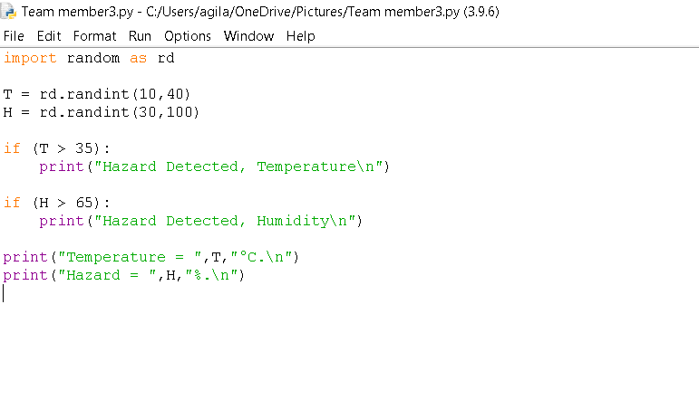

**Result:**

